Cloud to Ground AI
User Guide — Install & Setup (v1.3)

What it is
Cloud to Ground AI is a small Mac menu-bar app that sets up a private, local AI on your own computer and connects it to Claude. It installs IBM's Granite model (through a free tool called Ollama) and a small helper that lets Claude hand off the mechanical, repetitive parts of a task to that local model instead of doing them in the cloud.
The result: you use fewer cloud tokens for the same work, and your files and conversations never leave your Mac. You set it up once, and after that it runs quietly in the background. You keep using Claude exactly the way you do now.
Please email carlanotech@pm.me with any feedback. We are keeping this free until fall 2026 just for users to try it and are hoping to hear back. We will probably charge an easy to justify subscription amount, $30 a year or something, for updates and to cover the initial effort.
Note: you use your own Claude app and subscription. Cloud to Ground AI doesn't include Claude — it just connects Claude to the local model on your Mac.

Better for the environment
The name says it: Cloud to Ground. The whole idea is to bring as much of the work down out of the cloud and onto the ground — your own computer — as makes sense, because that's lighter on the planet.
Every task a large cloud data center runs draws power from the grid, and often water for cooling. When Claude hands the mechanical, repetitive part of a job to the model on your Mac instead, that part simply never spins up cloud hardware at all. Apple Silicon is remarkably power-efficient — it sips energy next to a rack of data-center GPUs — and it only draws meaningful power in the seconds it's actually generating an answer. The rest of the time it's practically idle.
The split is deliberate. Claude stays the “senior” for the hard reasoning that genuinely benefits from a big cloud model, while the local model does the “junior” work — the repetitive bulk. So you cut the cloud energy for the majority of the work while keeping cloud quality exactly where it matters.
And if your Mac runs on solar or another renewable source, the footprint of that local work can be close to nothing. The greenest task is the one that never had to leave your desk.

What you'll need
- An Apple Silicon Mac (M1 or newer).
- macOS 14 (Sonoma) or newer.
- At least 16 GB of memory (RAM). This matters: the local model needs room to run. On less than 16 GB it will be too slow to be useful. 24 GB or more is recommended if you want to use the larger model.
- About 6 GB of free disk space for the model.
- An internet connection for the one-time setup (to download Ollama and the model). After that, delegation works offline.
- Your own Claude account and subscription

Installing the app
- Open the Cloud_to_Ground_AI_v1.3.dmg file you downloaded.
- In the window that appears, drag the Cloud to Ground AI icon onto the Applications folder shortcut.
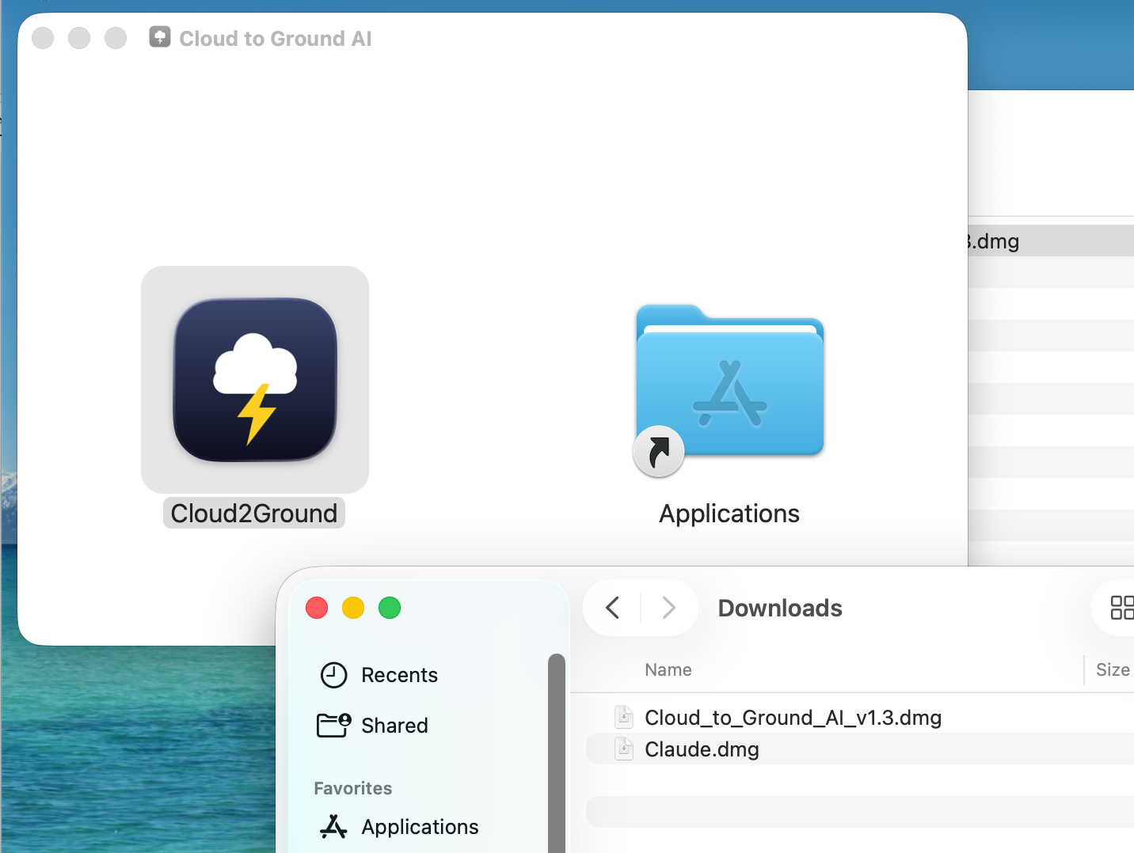
- Open your Applications folder and double-click Cloud to Ground AI. The first time, macOS may ask you to confirm you want to open it — click Open.
- A small cloud-and-lightning icon appears in the menu bar at the top-right of your screen. That's the app running.
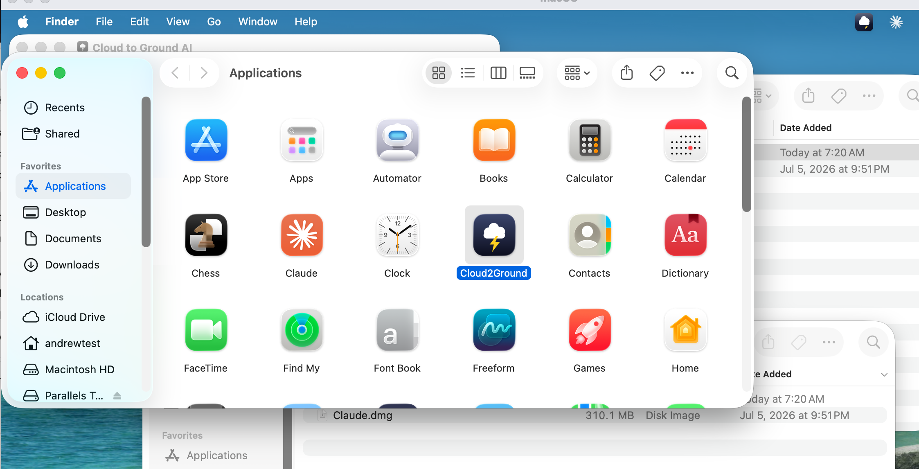

Setting it up (the first-run wizard)
The first time you open the app, a Setup window walks you through six steps. Work down the list — each one turns green when it's done. You can close this window and come back to it any time from the menu-bar icon; every step is safe to run again.

Step 1 — Install Ollama
Ollama is the free tool that runs the local model. If it's already on your Mac, this step is already green. If not, the app installs it for you (using Homebrew if you have it). If you don't have Homebrew, the app shows a link to download Ollama directly — click it, install Ollama, then come back and run this step again.

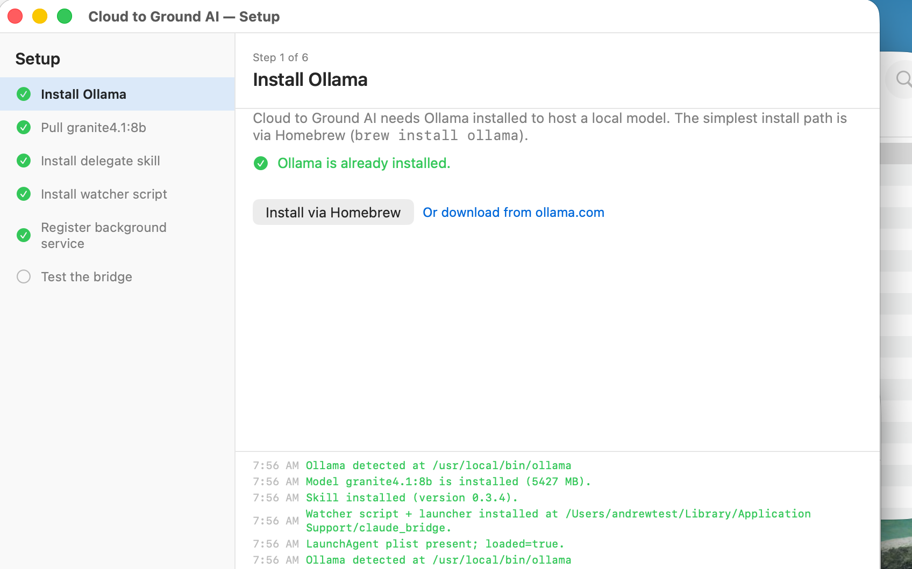Step 2 — Pull the model
This downloads the local AI model (granite4.1:8b, about 5 GB) — a one-time download that can take several minutes depending on your connection. If your Mac has plenty of memory (24 GB+), you can choose the larger model for better answers; otherwise the standard 8b model is the right choice.

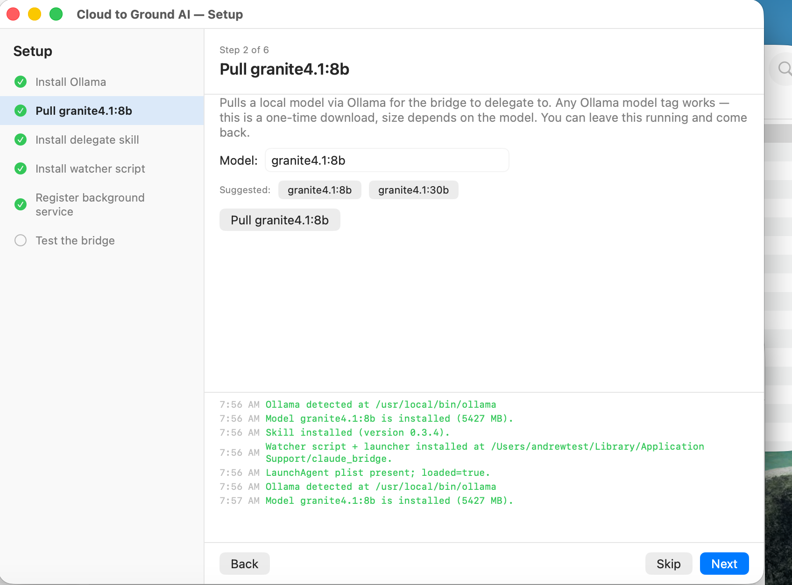Step 3 — Install the delegate skill
This adds the small “ollama-delegate” skill to Claude so Claude knows how and when to hand work to your local model.

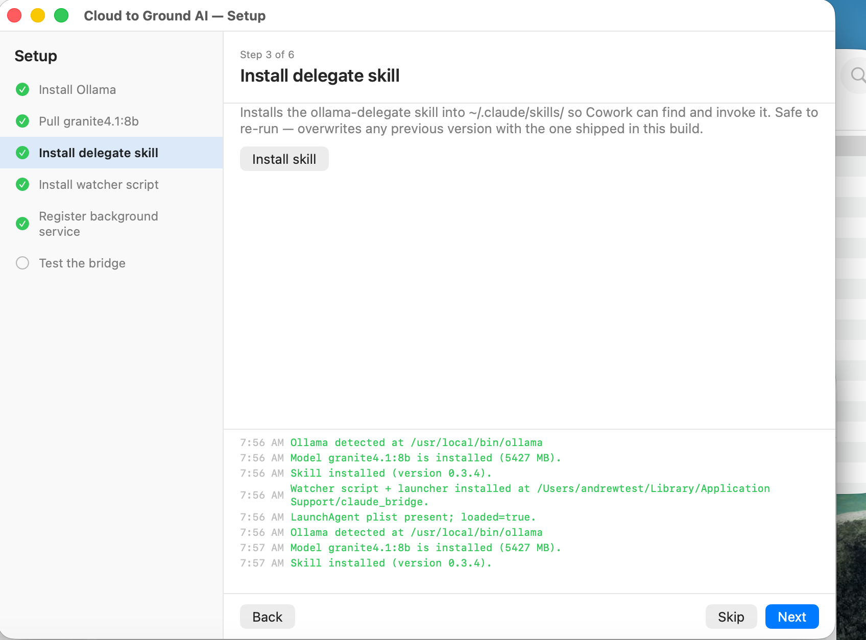

Step 4 — Install the watcher script
This installs the little background helper that listens for Claude's requests, runs the model, and hands the answer back.
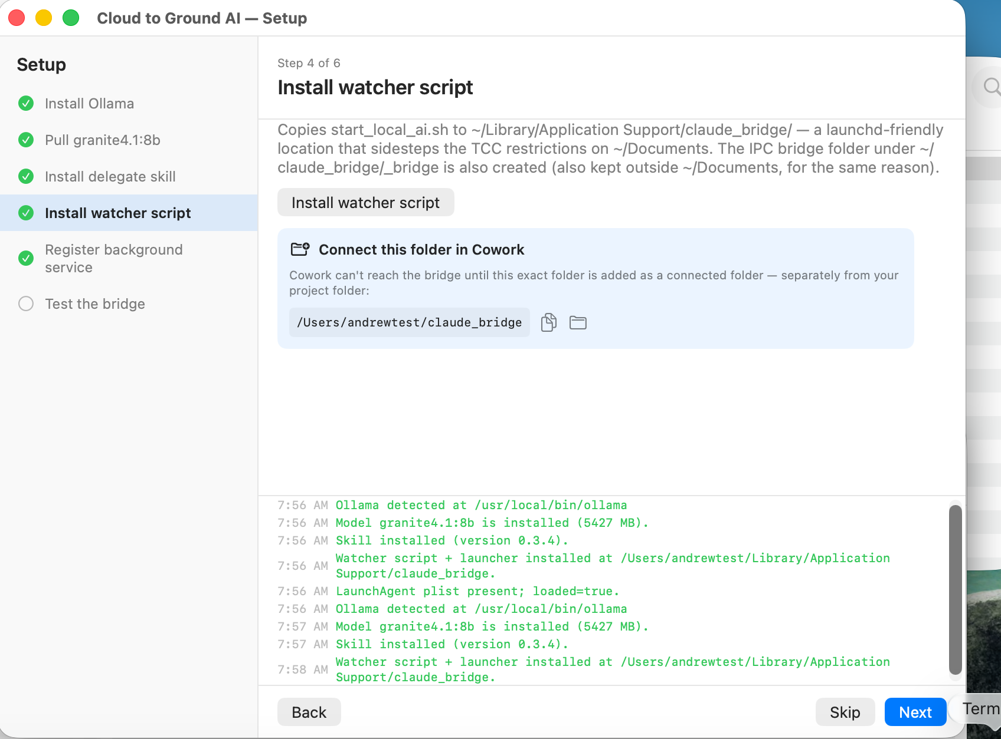

Step 5 — Register the background service
This lets the helper start automatically and keep running. The first time, macOS shows a notice that “Cloud to Ground AI” was added to your background items — that's expected and fine. If the next step doesn't work, open System Settings → General → Login Items & Extensions and make sure Cloud to Ground AI is turned on under “Allow in the Background.”

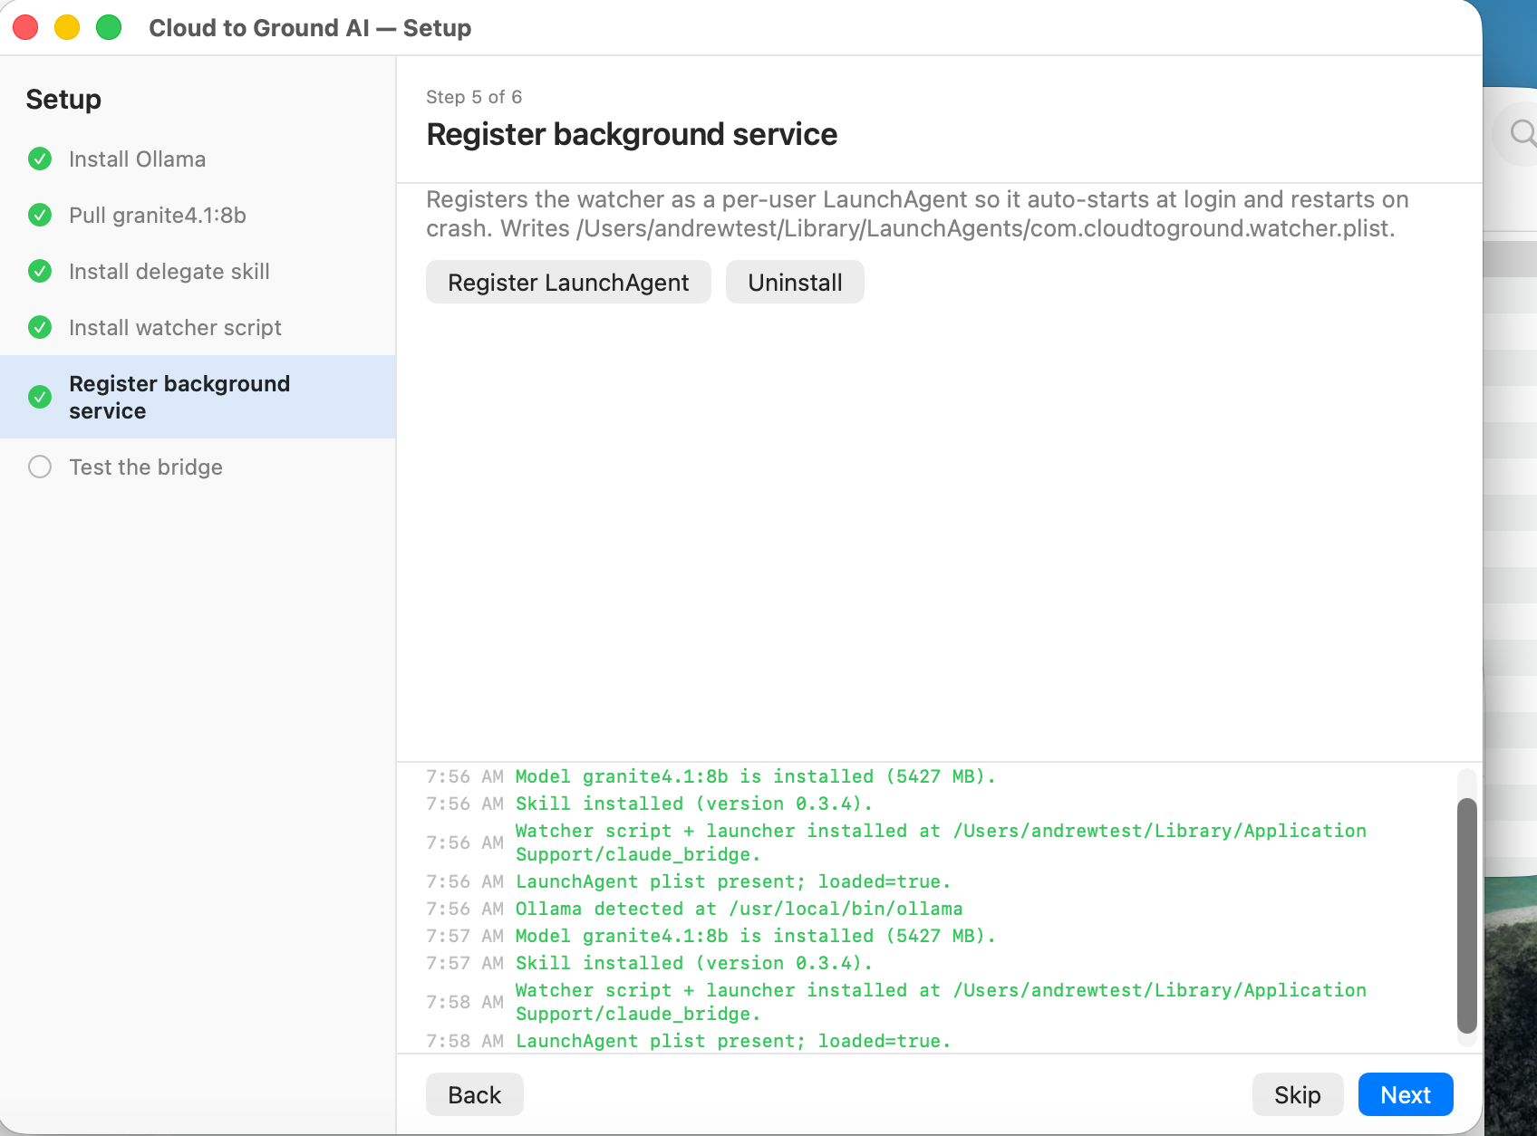

Step 6 — Test the bridge
This sends a real request to your local model and waits for it to answer, proving the whole thing works end to end. On a capable Mac it turns green in a few seconds. The very first response can take a minute or two, because the model has to load into memory the first time — that's normal. If it says the model was too slow, your Mac may not have enough memory to run it comfortably (see “If something goes wrong” below).
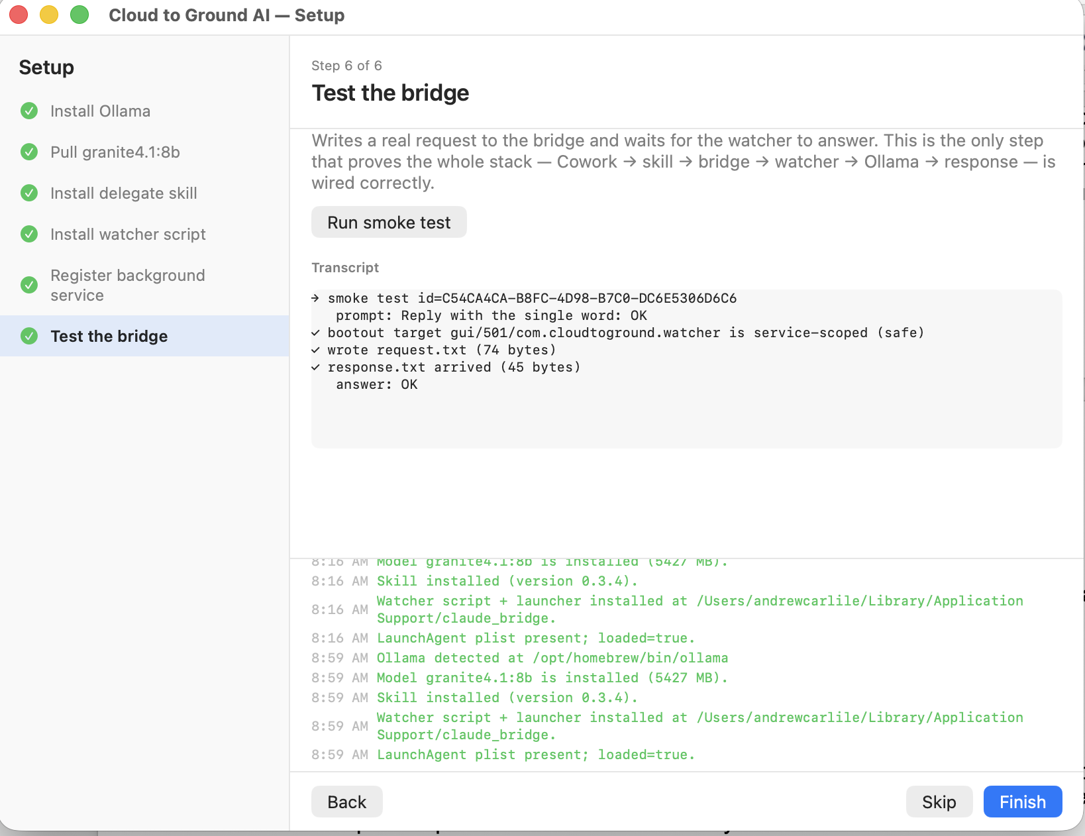
When all six steps are green, click Finish. Setup is done — you won't need to open the app again unless something breaks or you want to change a setting.

Using it day to day

One-time: connect the bridge folder to Cowork
For Claude to hand work to your local model, connect the folder the app created — it's called claude_bridge, in your home folder — as a folder in Claude Cowork. This is how Claude and the local model pass requests back and forth. You only do this once.
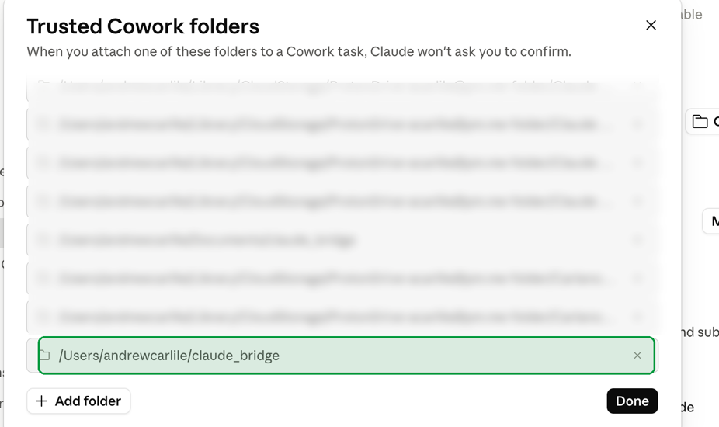

Then just work normally
After that, use Claude the way you always do. When a task has mechanical parts Claude can offload, it quietly sends them to the local model on your Mac and folds the results back into its answer. You don't have to do anything differently — you just spend fewer cloud tokens for the same work.

Working offline
No internet? Click the menu-bar icon and open the Ground chat to talk directly to the local model on your Mac.
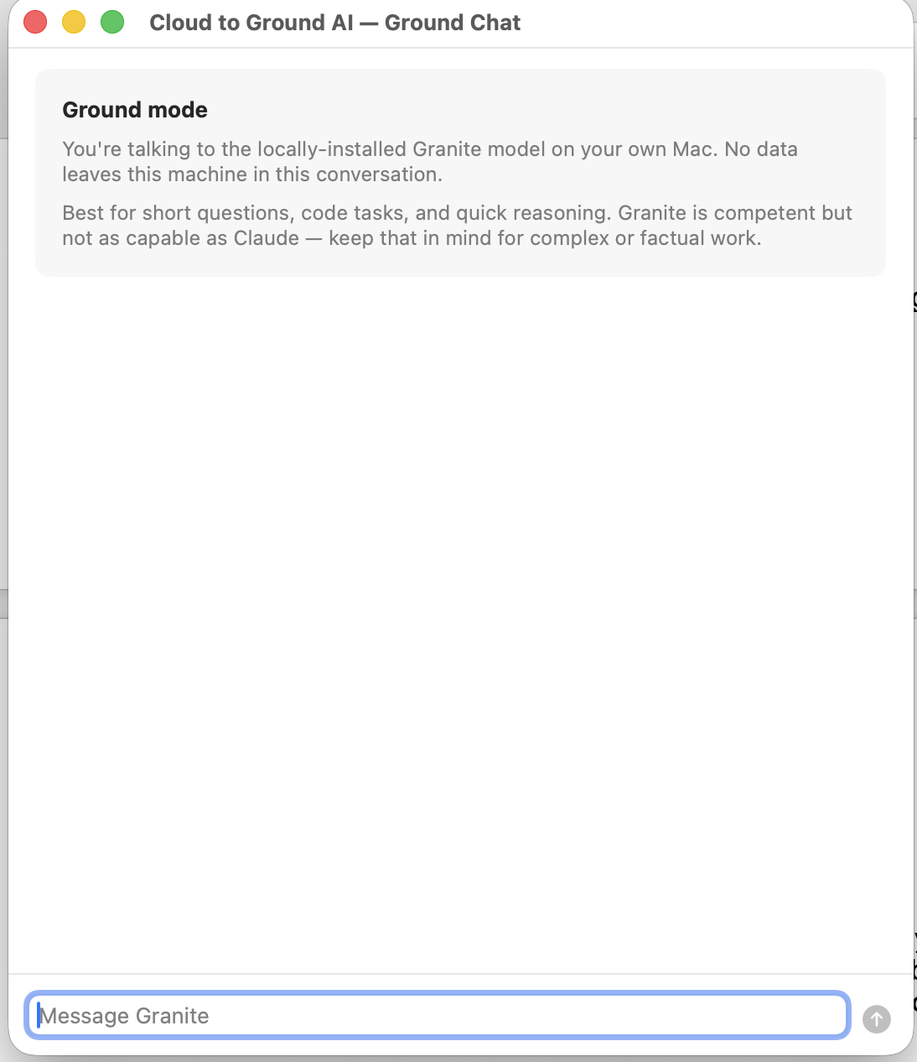

Checking on things
Click the menu-bar icon any time to see whether everything's running (Ollama, the model, and the background helper) and to open Settings.

If something goes wrong

“Test the bridge” fails or the answer is very slow
Make sure Ollama is running (it has its own icon in the menu bar). If your Mac has less than 16 GB of memory, the model is likely just too slow — try the standard 8b model rather than the larger one. The first answer after starting up is always the slowest, so give it a minute before deciding.

The background service was registered but nothing happens
Open System Settings → General → Login Items & Extensions and turn on Cloud to Ground AI under “Allow in the Background.”

A step didn't finish, or you want to redo the setup
Open Setup again from the menu-bar icon and re-run any step. Every step is safe to run more than once and will update things to the latest version.

Ollama won't install and you don't have Homebrew
Use the download link the app shows to install Ollama from ollama.com, then come back and run the Install Ollama step again.

Keeping the skill current as models change
The real product here isn't just the installer — it's the ollama-delegate skill, the piece that teaches Claude when a task is worth handing down to the local model and how to prompt that model to get a good answer. That's a moving target: Claude keeps improving, and local models keep getting better and change how they like to be prompted. So the skill is meant to be maintained, not frozen.
Cloud to Ground AI keeps it current for you. It checks for a newer version of the skill on its own and lets you know when one is available — and you can check any time in Settings → Updates. When you update, the latest routing logic and per-model tuning come with it, in place, with nothing to reinstall.
Behind the scenes, each model's settings live in a single tuning file that travels with those updates, so lessons learned from real-world use become improvements everyone gets. The project deliberately supports one model family at a time (Granite 4.1 today) to keep that tuning reliable and well-tested; when it's time to move to a newer or better model, a skill update brings the new tuning along with it — you don't have to work any of that out yourself.
Updates to the app itself arrive as a new download.

Removing it
To remove the app, quit it from the menu-bar icon and drag Cloud to Ground AI from your Applications folder to the Trash. The local model and Ollama stay on your Mac; if you want that disk space back, you can remove the model and Ollama separately.

